**Directory:**

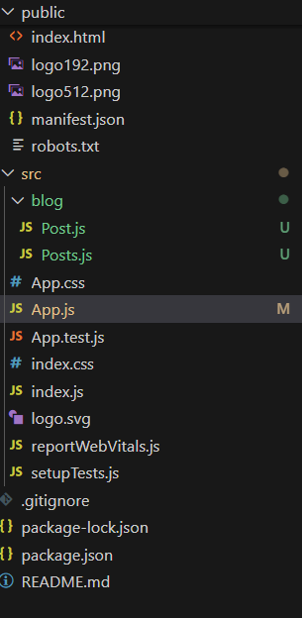

**Code for Post.js:**

import React from 'react';

class Post extends React.Component {

  render() {

    return (

      <div >

        <h3>{this.props.title}</h3>

        <p>{this.props.body}</p>

      </div>

    );

  }

}

export default Post;

**Code for Posts.js:**

// src/Posts.js

import React from 'react';

import Post from './Post';

class Posts extends React.Component {

  constructor(props) {

    super(props);

    this.state = {

      posts: [],

    };

  }

  loadPosts() {

    fetch("https://jsonplaceholder.typicode.com/posts")

      .then(response => response.json())

      .then(data => this.setState({ posts: data }))

      .catch(error => {

        alert("Error loading posts");

        console.error("Error:", error);

      });

  }

  componentDidMount() {

    this.loadPosts();

  }

  componentDidCatch(error, info) {

    alert("Something went wrong in Posts component.");

    console.error("Error caught:", error, info);

  }

  render() {

    return (

      <div>

        <h2>Blog Posts</h2>

        {this.state.posts.map(post => (

          <Post key={post.id} title={post.title} body={post.body} />

        ))}

      </div>

    );

  }

}

export default Posts;

**Code for App.js:**

import logo from './logo.svg';

import './App.css';

import Posts from './blog/Posts';

function App() {

  return (

<>

<Posts/>

</>

  );

}

export default App;

Output:

